Generalised Anxiety Scale
[derived from the Preschool Anxiety Scale; Spence et al. (2001)]
Below is a list of items that describe children. For each item, please circle the response that best describes your child. Please circle the 4 if the item is very often true, 3 if the item is quite often true, 2 if the item is sometimes true, 1 if the item is seldom true or if it is not true at all circle the 0. Please answer all the items as well as you can, even if some do not seem to apply to your child.
1. Has difficulty stopping him/herself from worrying 1 2 3 4 5
2. Is tense, restless or irritable due to worrying 1 2 3 4 5
3. has trouble sleeping due to worrying 1 2 3 4 5
4. spends a large part of each day worrying about various things 1 2 3 4 5
5. asks for reassurance when it doesn’t seem necessary. 1 2 3 4 5

Expected Apprehension Scale
NAO is a humanoid social robot which can talk, move, and light up. NAO is pictured below.
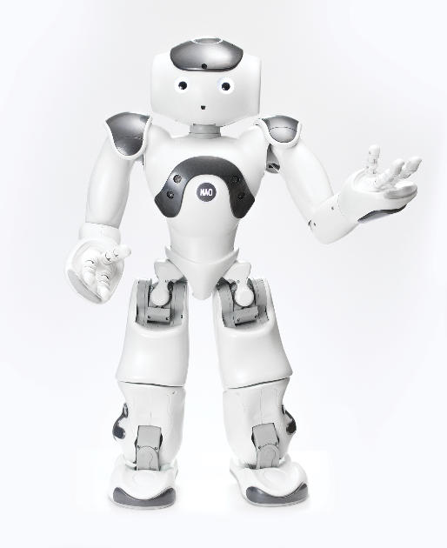
Please rate on the following scale the likelihood of your child to respond to the robot with:
Not at all likely Slightly likely moderately likely likely very likely
1 2 3 4 5
Apprehension:
Unease:
Discomfort:
Fear:
Disinterest:
Experiences with social robots
The following questions ask about your child’s experiences with social robots at home. A social robot is a robot that can interact, move, and communicate with people. They can be humanoid or resemble an animal.
Please indicate how many social robots/robot toy(s) are in your child’s home. If none, please write 0.
If your child has a social robot/robot toy(s) at home:
Write down how much time per week (minutes/hours) they spend playing with their social robot/robot toy(s).
Please write down the commercial name of each of the child’s robot/robot toy(s).
Please provide a brief description of the robot/robot toy(s) (e.g., does it talk, move, etc.)
Has your child watched any movies/TV shows/YouTube videos about robots?
If yes, please name the title of those robot movies/shows/videos your child has watched here:
Please select a response from either: strongly disagree; disagree; neither agree nor disagree; agree; strongly agree; or NA (not applicable), that best describes your feeling about social robots.
Social robots will help my child learn. | Strongly disagree  Disagree  Neither agree not disagree  Agree  Strongly agree  NA
Social robots will help my child’s education. | Strongly disagree  Disagree  Neither agree not disagree  Agree  Strongly agree  NA
Every home should have a social robot. | Strongly disagree  Disagree  Neither agree not disagree  Agree  Strongly agree  NA
Children should have a social robot at childcare/kindergarten/preschool. | Strongly disagree  Disagree  Neither agree not disagree  Agree  Strongly agree  NA
My child likes to play with social robots. | Strongly disagree  Disagree  Neither agree not disagree  Agree  Strongly agree  NA
My child likes to talk to social robots | Strongly disagree  Disagree  Neither agree not disagree  Agree  Strongly agree  NA

Demographic Questionnaire
The following questions are related to general information about your child and family. Where possible, please answer for both parents (e.g. step-parent, guardian, etc. who functions as a parent in the child’s home).
If your child does not have contact with one of their parents, please state NA (not applicable).
If you have more than one child participating in the study, please complete two different questionnaires for each child.
What age is your child in years?
What is your marital status? | Married or de facto  Divorced or separated  Single and never married
What is the mother’s age?
What is the father’s age?
What is your child’s gender? | Male  Female  Other
What language(s) does your child speak at home?
What is the cultural background (e.g., Australian, New Zealander, Chinese) of the child’s mother?
What is the cultural background (e.g., Australian, New Zealander, Chinese) of the child’s father?
Has your child been diagnosed with any developmental or behavioural problems? | Yes  No
If so, please describe here.
Has your child been diagnosed with any hearing, eyesight, or any serious illness or injury (e.g., broken arm?) | Yes  No
In a typical week, how many hours does the child’s mother work?
In a typical week, how many hours does the child’s father work?
What is the highest level of education completed by the child’s mother? | Less than Year 10  Year 10 or equivalent (e.g. School Certificate)  Year 12 or equivalent (e.g., High School Certificate)  Trade, technical, or vocational training  Bachelor’s degree  Post-graduate degree  Other (please specify): ________
What is the highest level of education completed by the child’s father? | Less than grade 10  Grade 10  High school  Trade, technical, or vocational training  Bachelor’s degree  Post-graduate degree  Other (please specify): ________
What is the child’s mother’s occupation?
What is the child’s father’s occupation?
Does your child have any siblings? If so, please indicate their age.

To help us organise a day for your child’s participation at their day-care centre, please indicate the days your child attends the service:
- Monday
- Tuesday
- Wednesday
- Thursday
- Friday

